Single ver 0.3 Reference Manual

Table of Contents

- About Single
- Installation
- Running the program
- “Camera Configuration” Window
- “PMA Recorder” Window
- Shutting down the program
- Troubleshooting

1. About Single

Single is a data acquisition application that records the images taken by Andor iXon EMCCD Camera (http://www.andor.com/scientific_cameras/ixon/) as PMA files. The PMA files are analyzed by custom written IDL and MATLAB scripts, to generate smFRET traces and histograms.

Single was written in Visual C++ 6.0 in the beginning, but the revised version documented in this manual was rewritten in Visual C++ .NET 2003. It is a very simple small program, but has been good enough to take a lot of good smFRET data for many years.

2. Installation

1) Download and unzip the “Single Installation.zip” where you want to install the Single program. In this example, it is assumed that the program is installed at “C:\Documents and Settings\XXX\My Documents\Single”. Unzip the “Single Installation.zip” there. Or, you unzip the installation file and move the “Single” directory under “C:\Documents and Settings\XXX\My Documents\”. Single directory contains following subdirectories.

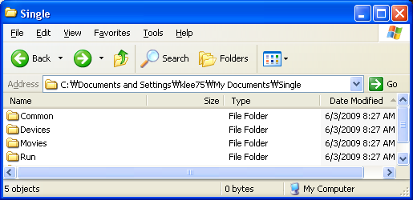

2) The executable file, “Single.exe”, is under \Run\

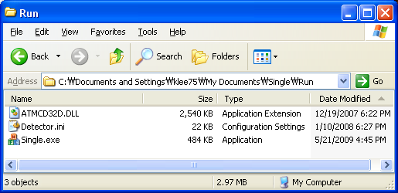

3) Run Single.exe by right-clicking and choosing “Run as Administrator” and an alert window will pop up. Click “OK”

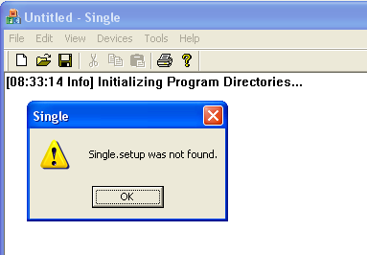

4) Another pop up will ask you to select a directory. Click “OK”

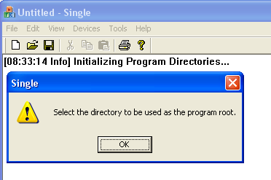

5) Click “Select Path” in the chosen directory. In this example, do it in the following directory, “C:\Documents and Settings\XXX\My Documents\Single.” This is the default directory in which your pma movies will be saved. You can change it later using the “Set Path” button in the PMA recorder program.

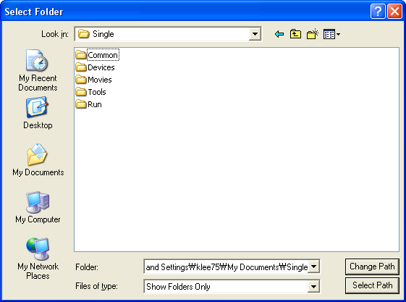

6) Now, you will see “Single.setup” file in the “\Run\” directory.

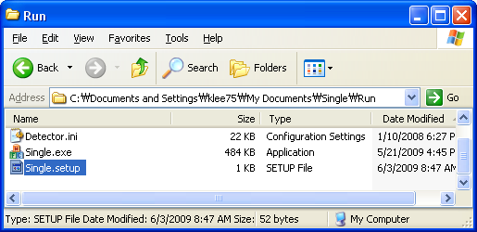

7) Installation is done.

3. Running the Program

0) Make sure that your Andor camera is installed and running properly. It can be tested by running a data acquisition program from Andor, such as “Andor Solis”.

1) Run “Single.exe” by right-clicking and choosing Run as Adminstrator. IMPORTANT- single will not work correctly unless it is run in administrator mode in Windows 7! The camera might initialize, but you will not be able to record movies. You need to do this every single time you initialize the program.

2) Select “Devices” – “Camera”.
This initializes the Andor camera and opens camera configuration window. It takes ~20 s.

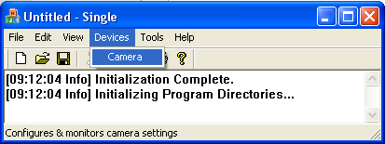

3) “Camera Configuration” window pops up.

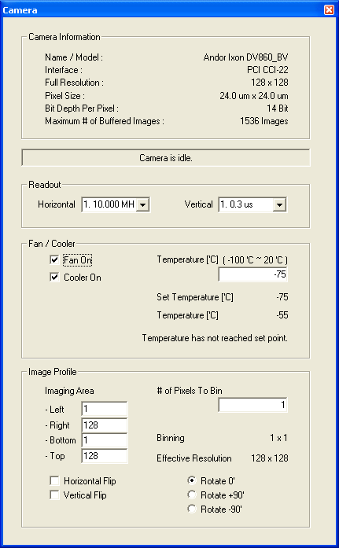
4) Check and adjust configuration and close the window. “Single” saves the settings, when this window is closed, and the last settings are loaded when you run Single next time.

5) Select “Tools” – “PMA Recorder”

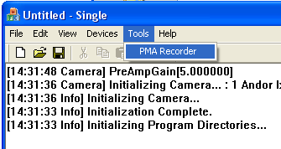

6) “PMA Recorder” window pops up.
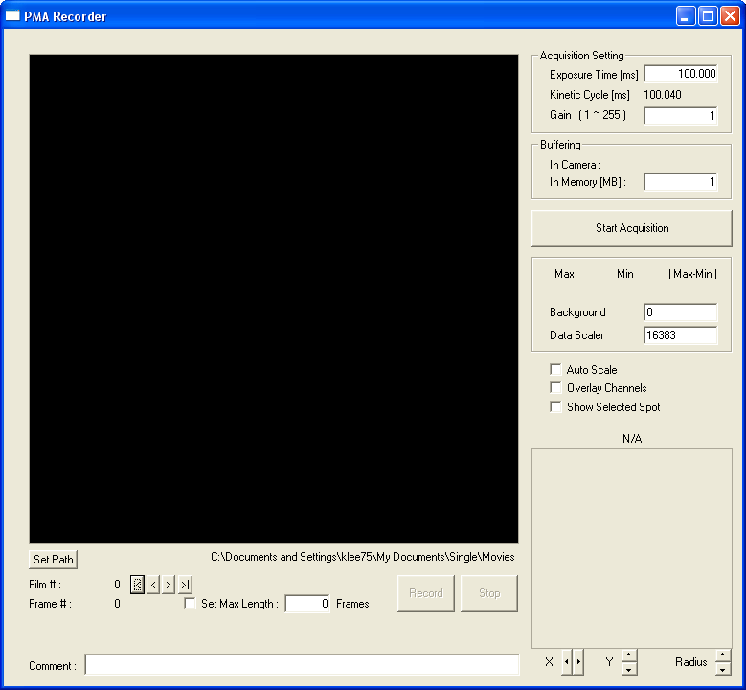

7) Record images as PMA files.
4. “Camera Configuration” Window

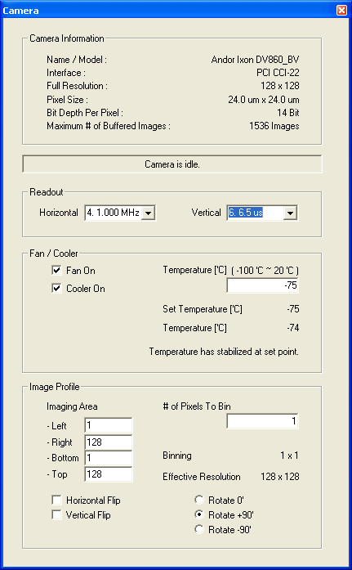

1) Camera information. It displays useful information about the camera.

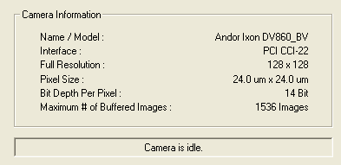

“Bit depth Per Pixel” tells you how many bits the camera uses to store the intensity of one pixel. In this case (14 bits), intensity ranges from 0 to16383.

“Max # of Buffered Images” tells you how many images (frames) can be temporarily stored in the Andor camera memory before it is transferred to a PC and written as a PMA file.

Note that the Andor camera shown here is not a typically used Andor camera for smFRET in Ha Lab. The latter has the full resolution of 512 x 512, the pixel size of 16um x 16um and ~90 images can be buffered in the internal memory.

2) Readout speed configuration.

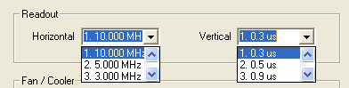

These two drop-down list set how fast the camera read out the intensity information in its pixels (To understand better how it reads out the data you can refer the Andor camera manual). You can set horizontal readout speed and vertical readout speed separately. Different readout speeds are listed in descending order for both horizontal and vertical readout speeds.

Basically, higher readout speed enables you to use better time resolution, but leads to worse SNR.

However, since time resolution is more important in our application, we have been setting the values for maximum readout speed, i.e. 10MHz & 0.3us, and it has been good enough.

3) Fan / Cooler. You can turn on/off the fan and the cooler, and set the cooling temperature.

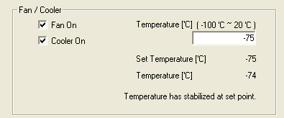

“Fan On”: It is highly recommended to leave the fan on. This function is reserved only for the case the noise from the fan is an issue.

“Cooler On”: Turn the cooler on and set the cooling temperature. Status message at the bottom tells you whether cooling function is turned off or temperature has stabilized.

4) Imaging area can be changed by setting “Left”, “Right”, “Bottom”, “Top”.

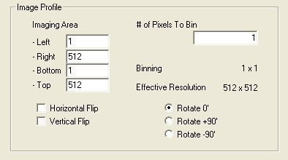

By setting (L, R, B, T) = (1, 512, 1, 512), you get the effective resolution of 512 x 512, which is the default. Sometimes, (1, 512, 1, 256) or (1, 512, 128) can be used to get half image or quarter image. The reason of using half or quarter image is to get better time resolution. The smaller the image is the better time resolution you can set. For example, for 512 x 512, the best time resolution is ~33ms, but with 512 x 256, it is ~ 16ms.

“# of Pixels To Bin”: Instead of changing image size, you can combine multiple pixels into one, to get smaller effective resolution and better time resolution. For example, by setting “# of Pixels To Bin” = 2, you combine 2 x 2 = 4 pixels into one, and you get the effective resolution of 256 x 256. This leads to better SNR “per pixel” and better time resolution.

“Horizontal Flip / Vertical Flip / Rotate 0, +90, -90”:
In Ha Lab, we want to have the donor channel on the left, i.e. (1~256, 1~512) and the acceptor channel on the right, i.e. (257~512, 1~512). Depending on the way the camera is mounted, you may need to rotate and flip the image, to have the donor channel on the left and the acceptor channel on the right.

5. “PMA Recorder” Window

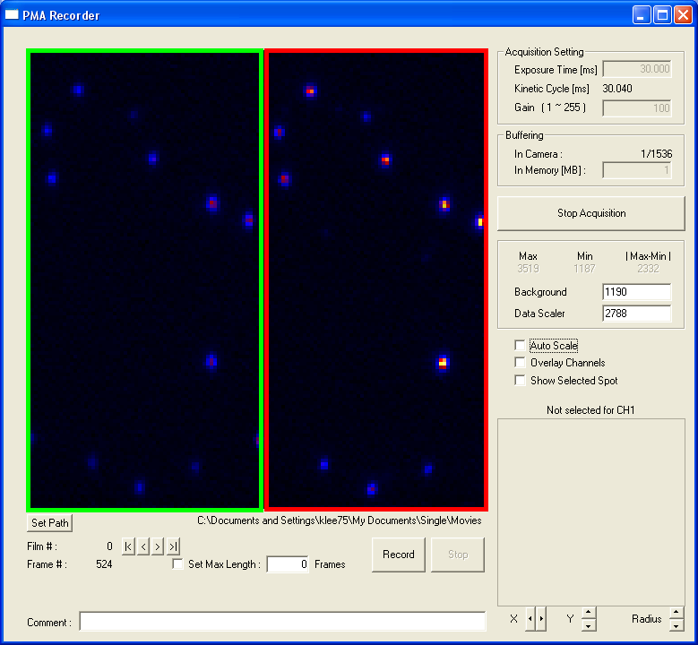

Donor Channel on the left
Acceptor Channel on the right

1) First of all, set the directory where PMA files will be saved. If this is not set properly, entire data can be lost, so it is important to check this again.

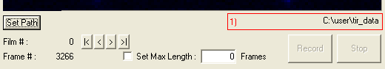

The directory which is selected now is shown in 1) box. In order to select another directory, Click “Set Path”, then “Select Folder” window will pop up. Choose the directory and click “Select Path” button in the chosen directory.

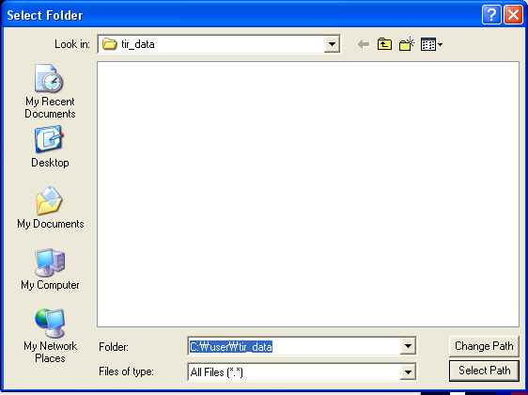

In order to use IDL scripts for following data analysis, it is recommended to use “C:\user\tir_data\” as the save directory, because some IDL scripts assume that PMA files are under the directory.

2) Second of all, “Exposure Time” and “Gain” should be set before data acquisition, because these parameters can not be changed during the acquisition. Thus, in order to change these parameters, data acquisition should be stopped, and restarted.

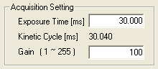

Whenever you change “Exposure Time”, “Kinetic Cycle Time” is updated. “Kinetic Cycle Time” is the period between frames, which is frame rate. Many misused “Exposure Time” as frame rate since two values are very similar, but actually they are different.

When the set “Exposure Time” is not supported by the camera, the following alert window pops up and tells the closest available value.

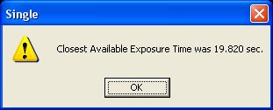

“Gain”: You can increase the EMCCD gain value if your signal is not strong enough. However, increasing more than enough is not recommended. The maximum EM gain in “Single” can be smaller than the real maximum EM gain that the camera can get.

(The following text taken from “Andor Software Development Kit”,
unsigned int WINAPI SetEMAdvanced(int state)
Description This function turns on and off access to higher EM gain levels within the SDK. Typically,
optimal signal to noise ratio and dynamic range is achieved between x1 to x300 EM Gain.
Higher gains of > x300 are recommended for single photon counting only. Before using
higher levels, you should ensure that light levels do not exceed the regime of tens of
photons per pixel, otherwise accelerated ageing of the sensor can occur.

might be helpful for you understand why it is so.)

3) Thirdly, set how many megabytes of memory to be allocated to buffer acquired images. This also can not be changed during data acquisition, and needs to be set before data acquisition.

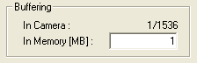

“In Camera”: How many images are temporarily stored in the internal memory of Andor camera and waiting to be retrieved by this program. If it reaches at “Max # of Buffered Images”, 1536 in this example, then it means that your acquisition is too slow and you may possibly lose some frames, and the acquisition will be aborted.

“In Memory”: Images retrieved from Andor camera are temporarily held by the program, before it is written to PMA files. So, you want to allocate enough memory space for this program not to be limited by too small memory. 100MB is more than enough for many cases. Actually, just 1MB works, but 100MB is good.

4) Click “Start Acquisition” to open the camera.

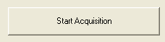 -> 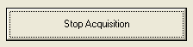

During data acquisition, “Start Acquisition” becomes “Stop Acquisition”. When you want to close the camera, then click “Stop Acquisition”.

5) Intensity information and 8-bit conversion

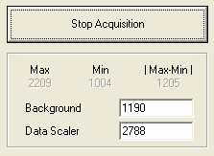

“Max”: The maximum intensity value among all the pixels in the current image (frame).
“Min”: The minimum intensity value among all the pixels in the current image.
“| Max-Min |”: The difference between “Max” and “Min”

This intensity information can be referenced to determine the proper “Background”, “Data Scaler” value. These two parameters are used to convert 14-bit intensity value of each pixel into 8-bit value. The conversion formula is as follows.

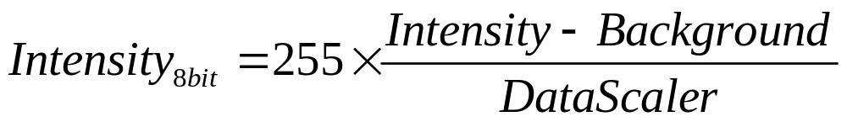

So, recommended settings are as follows.
“Background”: ~ “Min”
“Data Scaler”: ~ “| Max-Min |” or 1.2 x “| Max-Min |”

However, experienced TIR experimenters adjust those two values heuristically, looking how the image changes with respect to those two values, which is hard to document.

6) Checkboxes

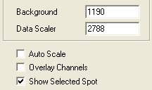

“Auto Scale”: Sets “Background” and “Data Scaler” automatically. This gives a guideline. (Tip: At first turn on this option, and then turn off and tune “Background” and “Data Scaler” a little more.) Do not turn on this option when you are recording PMA files.

“Overlay Channels”: Overlay the donor channel in green and the acceptor channel in red, to give you an idea how well two channels are aligned. For example, in the case of 512 x 512, pixels in (1~256, 1~512) are superposed on (256 + 1~256, 1~512) in green, while pixels in (257~512, 1~512) are superposed on (257~512 – 256, 1~512) in red.

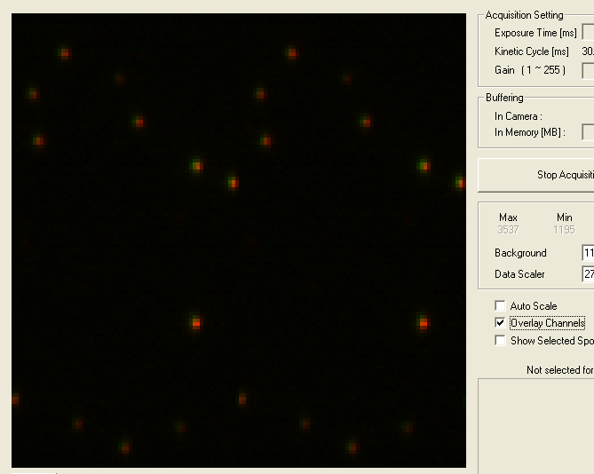

“Show Selected Spot”: When this option is on, a white circle is drawn around the selected pixel. Also, an the bottom-right corner of window, intensity of the pixel, the position of the pixel, and the magnified view of a small area around the selected pixel are displayed.

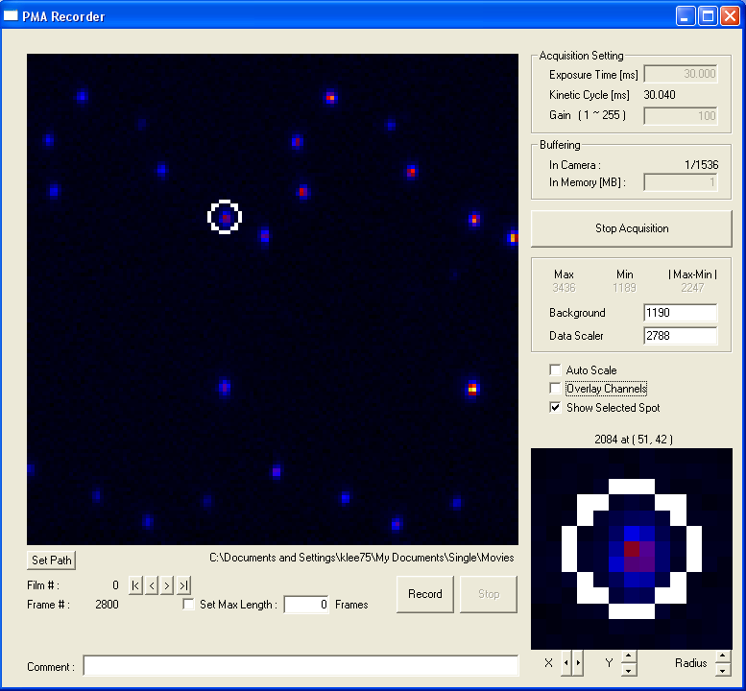

7) Frame #

The red 1) box shows how many frames have been acquired since the camera has been opened. When acquisition is stopped, this number is reset to 0.

8) In order to record a PMA file. Click “Record”, and click “Stop” when you want to stop.

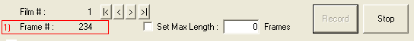

This time, while a PMA file is being recorded, the red 1) box shows how many frames have been recorded since the recording is started.

“Set Max Length”: If this option is turned on, the recording stops automatically after recording “Max Length”. For example, Set Max Length: 100 Frames and click “Record”, then, recording automatically stops, and recorded PMA file contains only 100 Frames.

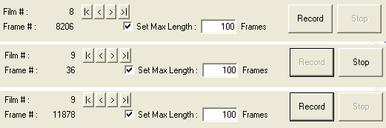

When you start recording a new PMA file, then “Film #” increases by 1, to tell you how many PMA files you have recorded in the directory.

9) When you want to overwrite one bad PMA file, then click .

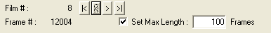

In this example, “Film #” goes back to 8, and you can overwrite “Film 9” by the next recording.

6. Shutting down the program

When you finished recording, click “Stop Acquisition” and close “Single” program.
Then you will see the following messages.

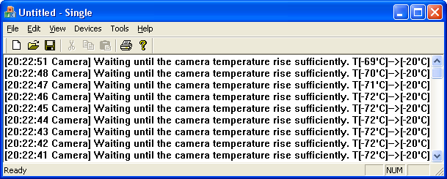

The reason that it does not close as soon as you close the program is to give the camera enough time to warm up back to (relatively) high temperature. According to the Andor manual, it is discouraged to leave the camera at very low temperature such as -75’C and turn off the program, because it can damage the camera. The manual recommends wait until it warms up to -20’C at least. When it reaches -20’C, “Single” releases the camera and automatically closes.

If you do not want to follow the recommendation and want to close the program immediately, you can always use “Window Task Manager” to kill this program.

7. Troubleshooting

1) If the program fails to open the camera, please try the following.
- Go to the directory where the device driver from ANDOR is installed (in most cases, “C:\Program Files\Andor iXon\” or “C:\Program Files\Andor SOLIS\”)
- Look for “atmcd32d.dll” and “detector.ini”
- Overwrite the files onto the “\Run\” directory (where “Single.exe” file is).

2) Single was developed on Windows XP. If you are using Windows Vista or Windows 7, you have to run the program with the administrator privilege in order for it to run correctly.

